Current Market View – August 2026
Investment Markets
Global Markets
Global markets staged a clean rebound in August 2026, unwinding July’s drawdown as earnings strength (led by mega-cap Nvidia) reasserted itself and macro conditions remained broadly supportive. Risk appetite rotated back toward AI-exposed sectors, lifting major global equity benchmarks: developed markets gained +2.6%, emerging markets +3.4%, with MSCI World and MSCI EM returning 2.9% and 3.6% respectively. The month was characterised by resilient data, improving liquidity conditions, and a rotation back into growth stocks.
Conversely, global bonds had a far tougher month, with Fed Chair Warsh’s hawkish Jackson Hole speech pushing rate-hike odds sharply higher, driving long-term Treasury yields toward 5.5% and flattening curves across developed markets—long-dated assets sold off as investors priced in stickier inflation and a slower path to policy easing. The major talking point was the announcement of U.S. Treasury buyback plans, which added volatility to the bond market; yields fell for 2 days before returning to new highs. Credit spreads widened modestly, particularly in rate-sensitive sectors, though balance-sheet strength kept the move orderly. In other markets, Europe tracked U.S. yield moves, and Japan faced renewed pressure from stickier inflation, which will likely see another rate hike.

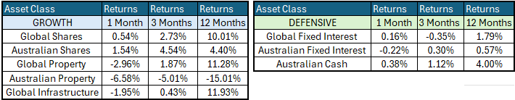
Global Share Markets
Global share markets were slightly up in August, with the surprisingly strongest market being the ASX200! The key driver was a decisive rebound in technology shares following Nvidia’s exceptional quarterly result, which reaffirmed the strength of the global AI investment cycle. Software outperformed hardware as investors rewarded companies actually earning profits from AI.
Gold surged +10%, silver +15%, and industrial metals strengthened amid concerns about fiscal sustainability and “dollar debasement.” Oil remained range-bound near USD $90/bbl as US/Iran tensions eased slightly. Agricultural commodities continued to push upwards on geopolitical risks and El Niño-related supply concerns.
August performance showed wide dispersion across global markets. The strongest markets were Taiwan, South Korea, the US, and Japan, each benefiting from semiconductor strength and renewed AI enthusiasm. While Australia has minimal exposure to AI, the ASX 200 benefited from exposure to AI-adjacent commodities such as copper.
France was the worst-performing major market, weighed down by rising bond yields and weakness in luxury goods. China continued to struggle with soft domestic demand and limited policy support, while UK equities declined as higher yields and a stronger sterling pressured energy and mining stocks.
Emerging markets outperformed developed markets, helped by a modestly weaker US dollar and firmer commodity prices.
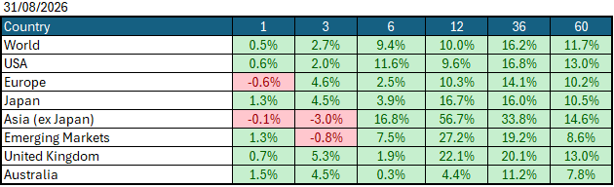
Data Source: AFM as of August 31, 2026.

Global Bond Markets
Global bond markets weakened in August 2026, delivering a second consecutive month of rising yields as investors priced in persistent inflation and a higher-for-longer policy stance from major central banks. Sovereign yields rose across nearly all developed markets, while emerging-market debt delivered positive returns thanks to currency strength and tighter spreads.
Interest rates were slightly higher in August, with the US 10-year Government bond rate rising to 4.75% and the UK 10-year Gilt rising to 5.06%
Domestic Bond Markets
Australian bond markets weakened through August as yields drifted higher across the curve, reflecting a combination of global rates repricing, persistent domestic inflation pressures and a clearly hawkish tone from the Reserve Bank of Australia. The move was broad-based, with a parallel shift of 6–12 basis points pushing the 10-year Commonwealth yield above 5.10%, a fresh cycle high and a level not seen since 2011. The RBA kept the cash rate unchanged at 4.35%, but the RBA continued to emphasise that inflation progress had stalled and that further tightening remained possible. The RBA highlighted upside risks stemming from elevated energy prices and weak domestic productivity growth.

Investment Climate
The U.S. investment climate in August sat in a tense balance between strong fundamentals and rising macro risks. Corporate earnings were resilient, with second-quarter earnings growth exceeding expectations, and AI-related capital investment continued to drive the economy. The broader economy remained solid, supported by healthy consumer spending and robust business investment tied to the ongoing AI build-out. Yet this strength was offset by a more fragile policy and geopolitical backdrop: inflation stayed above the Fed’s target, long-term Treasury yields climbed toward 5.5%, and Fed Chair Warsh’s hawkish Jackson Hole remarks pushed markets to price in a higher probability of a September rate hike. Overall, August felt like a resilient market environment supported by earnings and AI momentum, while rate volatility, elevated valuations, and policy uncertainty limited risk appetite.
Over the medium term, investors are encouraged by the anticipated productivity benefits from AI and the hyperscalers' investments in AI. However, the unsettled nature of the bond markets due to the war in Iran has put the handbrake on short-term encouragement. If the US changes its tone and begins raising interest rates under its new Federal Reserve Chairman, Kevin Warsh, the medium term could become much less encouraging.
Long-term investors are cautiously optimistic about a recovery period ahead. Global central banks continue to signal their resolve to bring inflation under control; however, economic data show signs of stabilisation despite elevated inflation, which could prompt central banks to raise interest rates in 2026.
The following commentary is based on month-end closing prices as of August 31, 2026:
Global share markets were mostly stronger in July, with gains in emerging markets and Australia offsetting weakness in Asia and Japan, where concerns about higher energy prices and a colder winter drove markets lower. Investors are unsure whether geopolitical events in the Middle East will end soon, with oil rising substantially over the month, reviving fears that inflation will not subside in the near term. The AUD/USD gained after US interest rate expectations shifted from 0.7022 to 0.7167 (+2.1%).
The U.S. Fed held the federal funds rate target range at 3.50%-3.75% at its meeting on 28/29 July 2026. Last month, soft-landing rhetoric came under pressure amid expected inflation gains following the oil price spike's impact on food prices, bringing the chances of a US rate hike back into focus. The next Fed meeting is on the 15th/16th September 2026.
The underlying short-term theme is "mildly cautious" for shares.
The situation in the Russia/Ukraine conflict remains unchanged, with the latest conflict between Israel and Gaza (Hamas) remaining unchanged as well. Volatility and risk increased as the USA/Israel moved towards a war with Iran.
Investor Focus
For Australia, investors focused on the following issues:
- Cost of living expenses and the impact on consumer spending.
- Commodity prices (post-China policy changes) and the impact on company profits.
- The level of interest rates and the delicate position of the RBA, given the global volatility in markets.
- Rising Oil Prices as conflicts with Iran re-escalate
- U.S. tariffs and the impact on Australia's exports (if any).
- Inflation (year-over-year) decreased to 3.8% in the June quarter, with the next quarterly CPI being released on October 28, 2026.
- Government spending and the rising debt level.
Currency
The Australian Dollar closed stronger, with AUD/USD at 0.7167 at the end of August 2026, up from 0.702 in July. As a 'risk currency', the Aussie dollar tends to sell off during global crises, as we saw in March, regardless of local conditions. The Aussie dollar was stronger against the USD and other major currencies in August, which is the usual pattern in booms, and persistent inflation here also raised the chances of RBA rate hikes. 2026 calendar year to date, the Australian Dollar is also up against all other major currencies.
Currency forecasters see the AUD/USD range between:
0.65 and 0.75 cents in the medium term and most likely to trade within the:
0.5500 to 0.7500 range in the longer term.

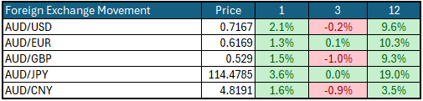

Australian Economy
Australia's latest GDP data for the first quarter of 2026 showed annual growth of 2.5%, down slightly from 2.6% in the final quarter of 2025. Unemployment rose to 4.5% in July, up from 4.4% in June 2026. The year-over-year (Y-O-Y) inflation rate fell to 3.5% from 3.8% in June 2026, but it remains outside the Reserve Bank's targeted 2% to 3% inflation range and could still prompt another rate hike later this year.
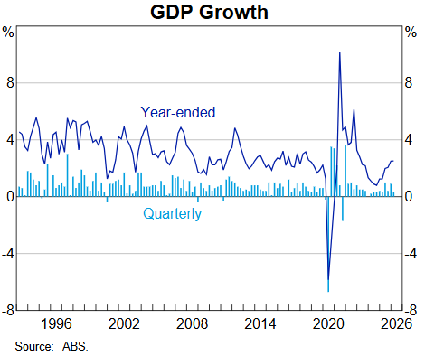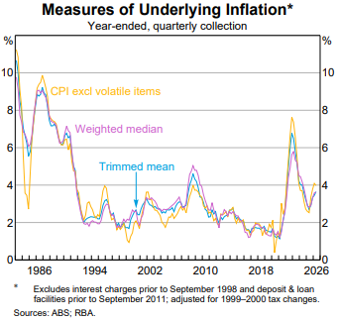

Current Market View

Domestic View
The overall investment view for shares is "cautious" over the short term, "cautiously optimistic" over the medium term, and "long run" as corporate profits continue to grow faster than inflation and as the need to build out data centres drives commodity prices higher.
The market is currently pricing in an interest rate hike on the 2nd/3rd of November 2026, due to a "hotter" inflation print in August that showed inflation is still outside the RBA's target range of 2-3% but has begun to stop trending back down towards the target band.

Global View
The global share market remains cautious, with concerns around AI profitability weighing on AI companies over the month, alongside the looming threat of a global inflation spike that could force many economies to raise interest rates. Given the current tensions in the Middle East, we could see a global slowdown in GDP growth, as energy production cannot keep pace with the rollout of AI data centres.
Where to From Here
- Continued shift from rules-based order and win-win multilateral trade to power-based order and win-lose trade deals. Trump did not start this. The shift started in the 2010s with the U.S./Europe letting Putin take Crimea in return for cheap gas for Germany/Europe, and the U.S./Japan letting China militarise the South China Sea. It has certainly accelerated under Trump. Lower cross-border trade & investment, more reliance on government subsidies & distortions, and inflationary onshoring of uneconomic industries.
- Sticky inflation - political pressure on central banks to keep rates low – populist pressure on governments to keep deficit spending. Tariffs + onshoring are adding to costs/prices. Bond yields may stay elevated or even drift higher, with risk of yield spikes or a sudden need for rate hikes, unsettling/breaking share markets.
- Share markets continue to be supported by good profit growth for now. Shares everywhere are expensive, buoyed by loose monetary & fiscal policies and a near-certainty that governments will throw 'free'/borrowed money at any problem.
- Commodities rally gathering pace, rising demand soaking up oversupply, AI/data centre boom (industrial metals, energy, water, land), global rearmament, especially Europe, Japan, Canada. This should support the ASX market, as long as banks avoid a local recession.

Footnote
This market update is written by Atlas Funds Management Pty Ltd for and on behalf of HNW Planning on 17 September 2026. Atlas Funds Management is an external asset consultant and consults to the HNW Investment Committee. Atlas Funds Management does not provide any general advice or personal advice regarding any potential investment in any financial products within the meaning of section 766B of the Corporations Act. No consideration has been made of any specific person's investment objectives, financial situation or needs. The provision of this presentation is not and should not be considered as a recommendation in relation to an investment in any entity or that an investment in any entity is a suitable investment for any specific person. Recipients should make their own enquiries and evaluations they consider appropriate to determine the suitability of any investment (including their investment objectives, financial situation, and particular needs) and should seek all necessary financial, legal, tax and investment advice. Atlas Funds Management Pty Ltd, it's directors and employees do not accept any liability for the results of any actions taken or not taken on the basis of information in this presentation, or for any negligent misstatements, errors or omissions. This presentation is not an advertisement and is not intended for public use or distribution. Past performance of a fund is no guarantee of its future performance.

